STUDENT NAME: OMKAR DRONACHARYA
ENROLLMENT NO:- ADT25SOCB0756
PROGRAMME YEAR:- FY
BRANCH:- CSE SOC
SUBJECT NAME:- PL
COURSE COORDINATOR:-
SUBJECT TEACHER:- POOJA PAWALE
ACADEMIC YEAR:- 2025-26
SEMESTER:- EVEN
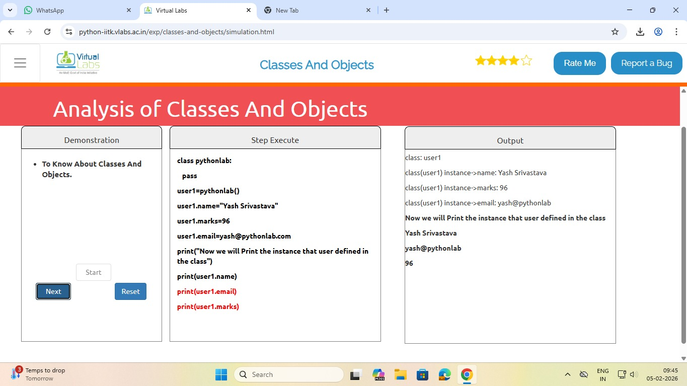











DECLARATION:-
I Omkar Dronacharya hereby declare that the virtual lab experiments included in this document have been performed by me as part of my academic activity. The screenshots submitted are genuine and taken during the actual execution of experiments
Student Signature:- Omkar Dronacharya
Date:- 5/2/26

